## **Objectives**

* List the features of ES6
* Explain JavaScript let
* Identify the differences between var and let

Create a React Application named “cricketapp” with the following components:

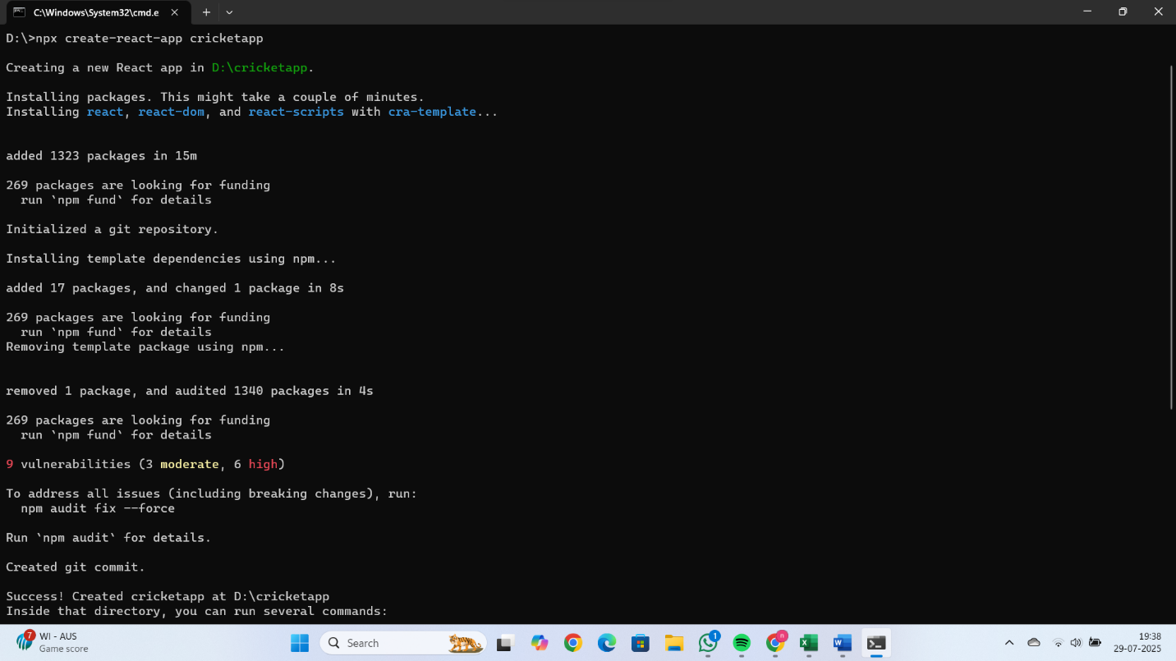

1. ListofPlayers

* Declare an array with 11 players and store details of their names and scores using the map feature of ES6

Filter the players with scores below 70 using arrow functions of ES6.

// src/ListofPlayers.js

import React from 'react';

function ListofPlayers() {

  const players = [

    { name: 'Virat Kohli', score: 80 },

    { name: 'Rohit Sharma', score: 90 },

    { name: 'KL Rahul', score: 60 },

    { name: 'Hardik Pandya', score: 75 },

    { name: 'Shikhar Dhawan', score: 68 },

    { name: 'Ravindra Jadeja', score: 85 },

    { name: 'Jasprit Bumrah', score: 40 },

    { name: 'Rishabh Pant', score: 78 },

    { name: 'Suryakumar Yadav', score: 55 },

    { name: 'Yuzvendra Chahal', score: 35 },

    { name: 'Mohammed Shami', score: 72 }

  ];

  // Filter players below score 70

  const below70 = players.filter(player => player.score < 70);

  return (

    <div>

      <h2>All Players</h2>

      <p>Total Players: {players.length}</p> {/* ✅ Total count added here */}

      <ul>

        {players.map((player, index) => (

          <li key={index}>

            {player.name} - {player.score}

          </li>

        ))}

      </ul>

      <h2>Players with score below 70</h2>

      <p>Count: {below70.length}</p> {/* ✅ Optional: count of filtered players */}

      <ul>

        {below70.map((player, index) => (

          <li key={index}>

            {player.name} - {player.score}

          </li>

        ))}

      </ul>

    </div>

  );

}

export default ListofPlayers;

1. IndianPlayers
   1. Display the Odd Team Player and Even Team players using the Destructuring features of ES6
   2. Declare two arrays T20players and RanjiTrophy players and merge the two arrays and display them using the Merge feature of ES6

// src/IndianPlayers.js

import React from 'react';

function IndianPlayers() {

  // a) Destructuring Odd & Even team players

  const oddTeam = ['Virat', 'Rahul', 'Jadeja', 'Pant', 'Shami'];

  const evenTeam = ['Rohit', 'Hardik', 'SKY', 'Bumrah', 'Ashwin'];

  const [odd1, odd2, ...restOdd] = oddTeam;

  const [even1, even2, ...restEven] = evenTeam;

  // b) Merge arrays using spread operator

  const T20players = ['Kohli', 'Rohit', 'Hardik'];

  const RanjiTrophy = ['Pujara', 'Rahane', 'Iyer'];

  const mergedPlayers = [...T20players, ...RanjiTrophy];

  return (

    <div>

      <h2>Odd Team Players</h2>

      <p>

        First: {odd1}, Second: {odd2}, Rest: {restOdd.join(', ')}

      </p>

      <h2>Even Team Players</h2>

      <p>

        First: {even1}, Second: {even2}, Rest: {restEven.join(', ')}

      </p>

      <h2>Merged Player List (T20 + Ranji Trophy)</h2>

      <p>{mergedPlayers.join(', ')}</p>

    </div>

  );

}

export default IndianPlayers;

Display these two components in the same home page using a simple if else in the flag variable.

**Output:**

When Flag=true

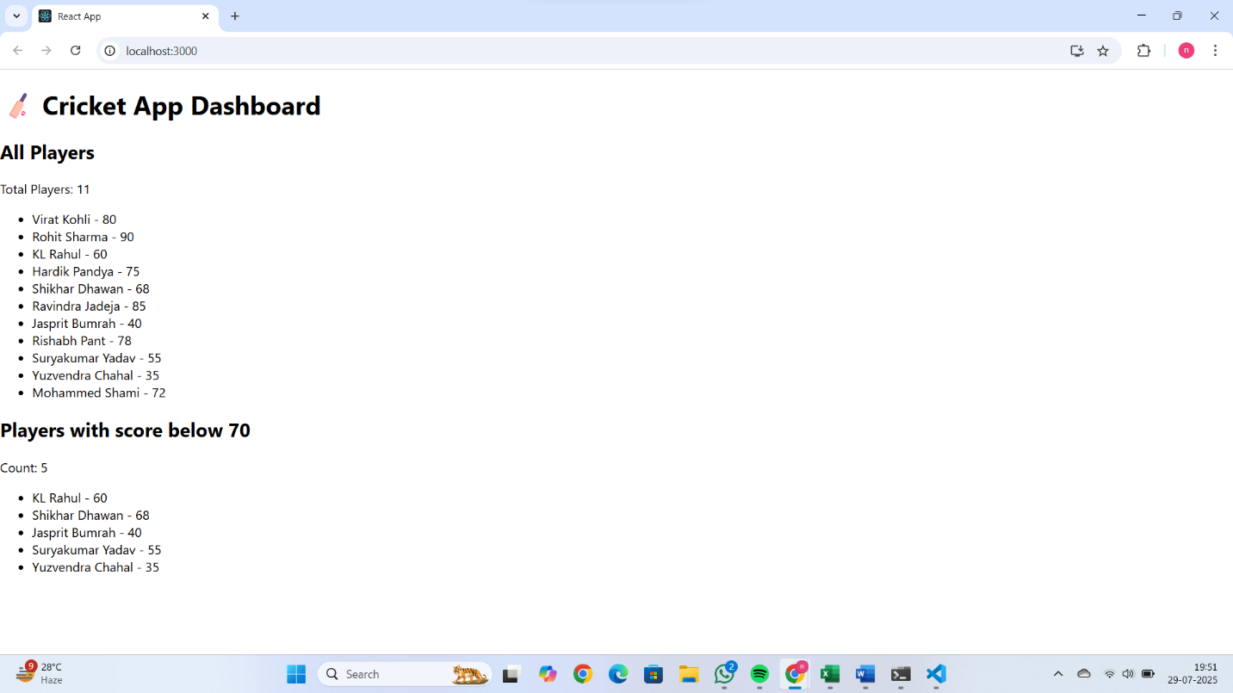

When Flag=false

